

**Fountain Creek Watershed, Flood Control, and Greenway District**

**Board of Directors Meeting Agenda**

**May 17, 2024 9am**

**In Person at Fountain City Hall, 116 S. Main Street, Fountain, CO 80817, or**

**Via Zoom: Zoom Meeting link: https://us06web.zoom.us/j/89493089235**

**Meetings are open to the public**

1. **Call to order and establish a quorum**
2. **Introduction of Guests**
3. **Approval of May Board Agenda**
4. **Board Member Comments**
5. **Consent Calendar**

These items listed below are considered routine and will be acted upon as a whole unless a specific item is called for discussion by a Board Member or citizen wishing to address the Board. Any items called for separate consideration shall be acted upon following Public Comment.

1. Approve minutes of previous meetings:
   1. April 19, 2024
2. Board Financial Report
3. District Reports (Executive Director, CAG, TAC, Outreach)
4. Approval of Invoices. There are sufficient funds to cover these invoices.

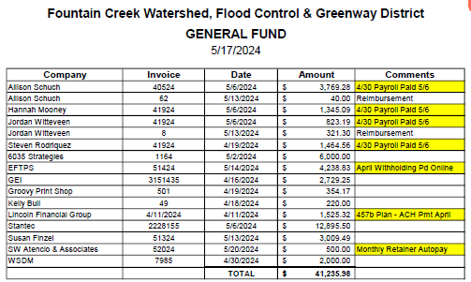

1. **Presentations** 
   1. Loop Project - John Kuosman | Water Practice Leader | Merrick & Company
   2. 2023 District Audit - Chris Jorgensen, Audit Principal, BiggsKofford, P.C.
2. **Executive Director Report**
3. **Committee Updates** 
   1. **HR/Contracts**
   2. **Finance -** June meeting, mid year review
   3. **Governance**
4. **Old Business**
5. **New Business** 
   1. Website accessibility Policy
   2. Remote work policy
   3. Letter of Support - Pikes Peak Waterways WaterSMART Grant
6. **Executive Session** - None
7. **Public Comment**

Citizens may address the District Board on items that are not on the agenda. The Board may not be able to provide an immediate answer but will direct Staff to follow up. Out of respect for the District and others in attendance please limit your comments to 3 minutes or less.

1. **Confirm Next Meetings - Via Zoom or in person at Fountain City Hall (116 S. Main St. Fountain, CO 80817)**
2. June/July - no meetings (7.17 USAFA Tour - RSVP needed)
3. Fri Aug 16, 9am - Trust for Public Land presentation
4. Fri Sept 20, 9am
5. Fri Oct 18, 9am
6. Fri Nov 15, 9am - Budget Hearing
7. December - no meeting
8. **Adjourn Board Meeting**