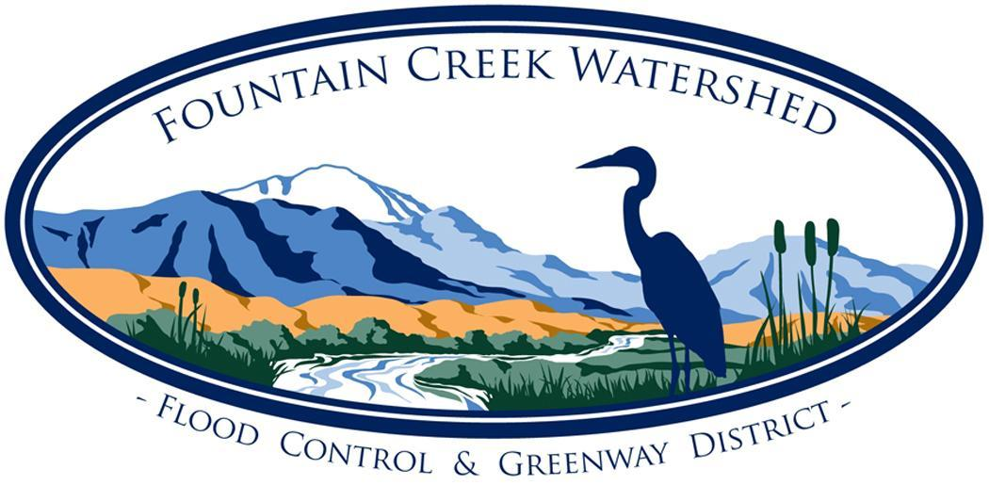
Fountain Creek Watershed, Flood Control, and Greenway District
Citizens Advisory Group Meeting Agenda Friday March 8th, 2024
Via Zoom:https://us06web.zoom.us/j/99749871376
(Meetings are open to the public)

- Call to Order, Establish Quorum and Introductions

- Approve Meeting Agenda

- Approve Minutes of Prior Meeting(s)
  - February 16, 2024

- Committee Member Comments
- Reports:
  - Governing Board – Alli/Terry
  - Projects - Alli
  - MMFAC - Alli
  - TAC – Mark/Annie
  - Website - Mary
  - WOC- Hannah/ Susan
  - AFCURE – Andra/Annie

- New Business:

- Ongoing Business:
  - State of the Watershed Discussion Continued
- Old Business:

- Presentations:
  - Water Hot Topics Panel:
    - Katie Helm- Conservation & Sustainability Manager, City of Fountain
    - Matthew Nelson- Arborist & Horticulturist, City of Manitou
    - Billy Richard- Nursery Manager, Ricks Garden Center
  - FCWD Year Ahead
    - Alli Schuch- Executive Director, Fountain Creek Watershed District
    - Mary Barber- Strategic Planning Discussion

- Public Comment:

- Next Meeting:
  - CAG: April 13, Zoom 9:30- 11:30 am

- Adjourn

